**Quarterly Report – Public Page**

**Date of Report:** 3rd Quarterly Report - August 2, 2023

**Contract Number:** *693JK32210015POTA*

**Prepared for:** *DOT-PHMSA*

**Project Title:** *Dynamic Geohazard Risk and Decision Support Platform*

**Prepared by:**  *Boston Geospatial, Inc.*

**Contact Information:**  *Justin Oliveira,* [*justin@bostongeospatial.com*](mailto:justin@bostongeospatial.com)*, 781-975-3748*

**For quarterly period ending:** *June 30, 2023*

**1: Items Completed During this Quarterly Period:**

A detailed overview of the progress this past quarter is provided in the various sections below.

Unrelated to any invoiceable item, we made progress on the development of our TAP. We have added a professor from University of Alberta to the TAP - his background is in geotechnical engineering and soil mechanics. We have also added an SME from DNV to the TAP - his background is in pipe-soil interactions and in addition to his SME capacity at DNV he is also responsible for fostering partnerships for research and solution development. In the coming months we will be continuing to engage with industry to begin adding operators to the TAP.

| ***Item #*** | ***Task #*** | ***Activity/Deliverable*** | ***Title*** |
| --- | --- | --- | --- |
| 6 | 2.1 | APDM Module | Research and develop protocol to read/write pipe attribute data from APDM |
| 7 | 2.2 | APDM Module | Submit APDM Interface Requirements Documentation |
| 9 | 0.1 | 3rd Quarterly Status Report | Submit 3rd quarterly report |

**2: Items Not-Completed During this Quarterly Period:**

| ***Item #*** | ***Task #*** | ***Activity/Deliverable*** | ***Title*** |
| --- | --- | --- | --- |
| 8 | 5.1 | Cost Estimation Module | Research and create rehabilitation cost estimation framework |

**3: Project Financial Tracking During this Quarterly Period:**

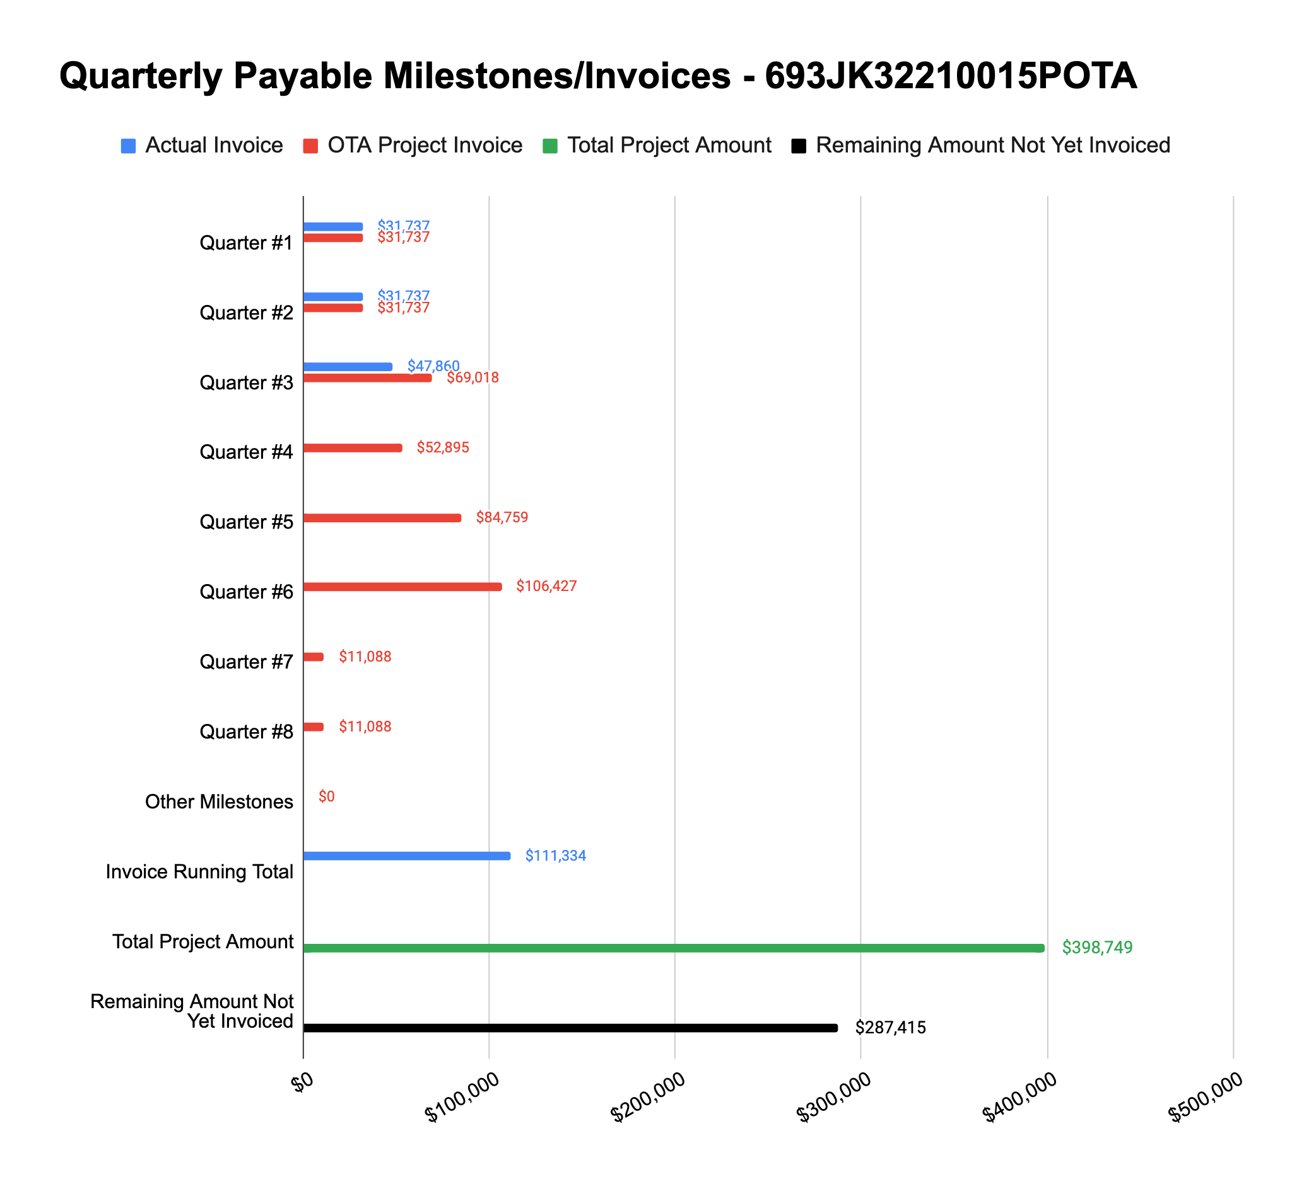

**4: Project Technical Status –**

**Item# 6 / Task# 2.1/ APDM Module / Research and develop protocol to read/write pipe attribute data from APDM**

Regarding Item #6 (APDM Module - Research and develop protocol to read/write pipe attribute data from APDM), we have continued progress on creating the framework and protocol to read and write pipe attribute data from an end-user APDM/UPDM. A couple months back, we procured the latest sample UPDM model from Esri and have since been unpacking the documentation and various pipe attribute fields to make progress. Because of delays in getting the necessary software licenses from Esri to unlock the needed development abilities within ArcGIS, we are a few weeks behind schedule in our research efforts (roughly 65% complete at the moment).

We have since finalized our research and experimentation into how to optimally interact with the Esri UPDM through the python engine within ArcGIS (ArcPy) to query and write back specific pipeline attributes (fields). These read/write actions along with any field mappings must be defined clearly enough to be applied to end-user models which may contain some amount of customization. Generally, the Esri APDM/UPDM data model standard is designed to be somewhat flexible for operators to have customization (whereas PODS is for the most part not), so this has been accounted for in the design of the APDM Module. The documentation stemming from this task covers the specific pipeline fields which are mandatory in end-users data models, as well as those which are optional. Guidance is provided on how end-users can bring their data model into compliance with the APDM Module to use this tool.

**Item# 7 / Task# 2.2/ APDM Module / Submit APDM Interface Requirements Documentation**

Regarding Item #7 (APDM Module - Submit APDM Interface Requirements Documentation), this task is tied to the completion of Item #6 - both of which are now complete. This document defines the end-user APDM requirements in order for the tool to run successfully - this includes how to set and apply any field mappings (as the naming convention for certain attributes may differ based on end-user customization). After completing Task 2.1, we took the research and lessons learned and created the Pipeline Data Model Interface Module Requirements Documentation (formerly called APDM Interface Requirements Documentation). We renamed this document to reflect the intent to expand support at a later date for other data models (e.g. PODS) in addition to the primary model standard (Esri UPDM) used in the baseline version of this tool. The document has been uploaded to the PRIMIS archive.

**Item# 8 / Task# 5.1/ Cost Estimation Module / Research and create rehabilitation cost estimation framework**

Regarding Item #8 (Cost Estimation Module - Research and create rehabilitation cost estimation framework), since the last update we have continued progress on developing a recommendation and subsequent cost estimation framework.

Once the stress margins have been estimated for the system within the tool, a rule-based algorithm will offer triage, rehabilitation, and/or replacement options for at-risk sections of piping based on the degree and type of margin excursion (longitudinal, hoop, or bi-axial). Triage options include reduction to a specified operating pressure or a follow-on field geohazard investigation; rehabilitation options are currently focused on the re-engineering of backfill to mitigate geohazard loads; and replacement options are currently focused on the complete removal and reinstallation of new steel pipe. From our initial research, neither Part 192 or 195 allow for the use of any expandable polymer-based lining as a temporary measure for repairing cast-iron piping - therefore rehabilitation options will exclude this.

As of the prior update, the remaining work left to be complete includes finalization of the: (i) algorithm flowchart directing the tool to develop triage, rehabilitation, and/or replacement options (now 100% complete); (ii) algorithm flowchart for performing of stress/margin sensitivity analysis to backfill parameter (now 90% complete); and (iii) algorithm flowchart for cost estimation for backfill re-engineering (now 60% complete). Work on the algorithm flowchart for performing stress/margin sensitivity will likely take another 1-2 weeks because we made the decision to add sensitivity analysis support for all model parameters (not just those related to the backfill). Work on algorithm flowchart for cost estimation for backfill re-engineering is progressing but taking longer than expected due to the lack of available detailed/published research in the cost estimating of this type. We have since engaged with cost estimating experts (including a former Enbridge SME) that is helping to point us in the right direction - we expect this workstream to take another 1-2 weeks to complete as well.

**Item# 9 / Task# 0.1/ 3rd Quarterly Status Report / Submit 3rd quarterly report**

Additional detail not necessary - this report constitutes the deliverable for Item# 9 / Task# 0.1. We plan to complete the work associated with Task 5.1 in the next couple weeks and include it in the 4th Quarterly Status Report (and associated invoice request) rather than issue another revision to this 3rd Quarterly Status Report.

**5: Project Schedule –**

Overall our project is about 2-3 weeks behind schedule - since our last update, this gap has been improving as we have accomplished risk reduction around the APDM Module and been fortunate enough to engage with cost SMEs to aid our research effort.